GDB Practice session

Getting Started

- Following are the directories available inside the programs directory :
  - sample_session
  - watchpoints
  - core_analysis
  - attach_det
  - threads
  - processes
  - c++

A note on using gdb commands

- Although all commands in gdb are full words, you can type any unambiguous prefix. For instance, p instead of print.

- Use the help command in gdb for a list of classes of commands. Then type help followed by a class name for a list of commands in that class. help cmd gives help on the command cmd e.g. help print will give information about the print command.

- For comprehensive coverage of gdb, read the Info pages. At the shell prompt, type info. When info starts, type mgdb<ENTER>. The gdb manual will be displayed. The gdb manual is a part of this training’s material

Compilation

- gcc flag –g needs to be used during compilation in order to use gdb with a program. Observe the same in the makefiles make_send and make_recv

- Compile the source files with the help of the makefiles provided:
make –f make_send
make –f make_recv

A sample gdb session

This section introduces you to the handful of commands that are enough to get started using the debugger.

Overview of the program

Please note that the number of message queues that can be created on a server is limited so do not leave a message queue opened if the program terminates. Whenever you exit the sending process using ctrl-c you must remove the message queue by using the following command:
ipcs
(to see the opened message queue ids)

ipcrm –q queue-id

The programs which we will be taking as sample programs are send_process.c and recv_process.c. They are compiled to create executables called debug_send and debug_ recv respectively. The working of these processes is simple. The send process is sending messages to the receive process and the receive process is displaying those messages. The message that is sent is based on user input. The user may input one or more of the following fields: name, employee id and extension. A bit flag is used to communicate which field is filled and which is not filled. Their means of communication is a message queue. You may ignore the intricacies of creating a message queue and sending and receiving messages from it.

Let us first run these programs without gdb. Open two terminals.
On one terminal, start the sending process:
./debug_send
On another terminal, start the receive process:
./debug_recv

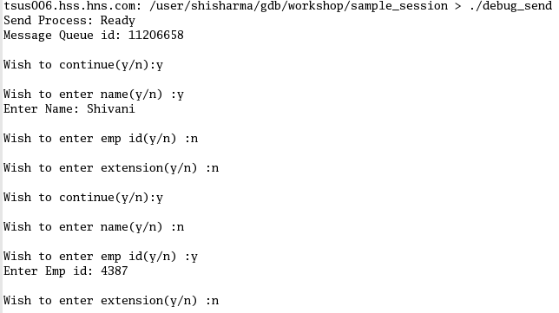

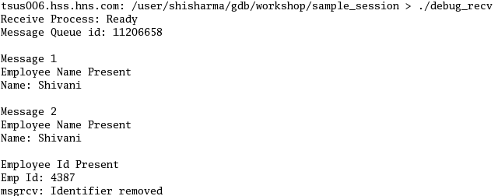

We can see there is a problem as the second message entered by the user did not contain the employee name, yet the receive process is displaying the employee name in the second message. The message which is being sent is not received or interpreted properly by the receiving process. Let us try to debug this problem using gdb.

Now, the problem may lie in the sending process or in the receiving process. Let us try to first debug the sending process.

$ gdb debug_send

(Note that $ represents the shell prompt)

You will now see the gdb prompt. Let us put a breakpoint on the function main.

(gdb) b main
Breakpoints can be put using either:
- the function name or
- the line number or
- source file name: line number

Now, run the program

(gdb) r

As soon as main function is entered, the program stops executing and the control comes to gdb.

Let us see the source code at this point in time:

(gdb) list

To see the source code around a particular line number, the list command can be given with the line number e.g. list 1
Now, we will step through the code one instruction at a time using the “next” command:

(gdb) n

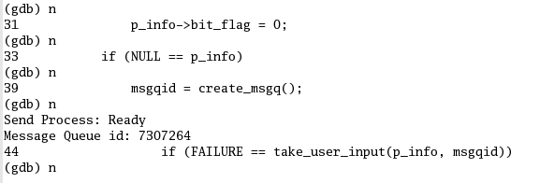

As the message queue gets created, i.e. after the function call create_msgq returns, let us execute the receive process on another terminal:
(Note that the receive process can run only after the message queue has been created by the sending process. This is because the receiving process is opening that same message queue for reading)

Execute the receive process on another terminal:

./debug_receive

Coming back to the send process terminal, give the same user input as given earlier. For the first message, fill only the employee name.

Let us step into the function send_info using the “step” command

(gdb) s

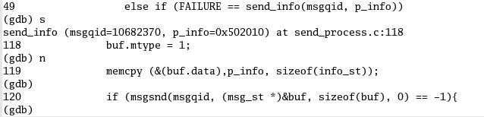

Before this statement gets executed i.e. before the message is sent towards the receive process,
Let us see the type of variable “buf” which is being sent using the “ptype” command

(gdb) pt buf

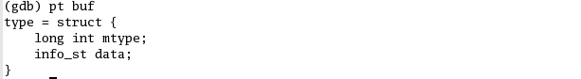

let us see the value of buf.data with the “print” command

(gdb) p buf.data

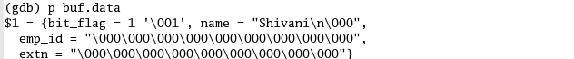

This time the value of data is perfectly fine, so we can let the program continue till the next time send_info is called for the second message. For this we will first put a breakpoint on send_info and then let the program continue execution on its own

(gdb) b send_info
(gdb) c

Now, for the second message give only the employee id in the input. When the program enters send_info, it stops. Again let us execute each instruction one by one.

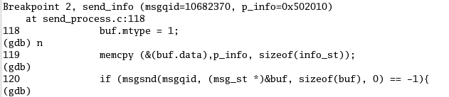

Let us see the value of buf.data at this point in time with the “print” command

(gdb) p buf.data

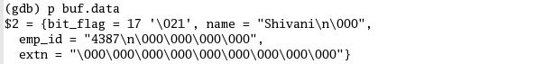

This time the value of bit_flag is not correct, it is also set for employee name. This implies that the bit_flag is not initialized again after sending the first message.

Now that we know the bug and its fix, let us first try the fix while debugging and see its effect. Let us make the value of bit_flag correct.

(gdb) p buf.data.bit_flag = 16

Now, let the program continue and see the message displayed on the receive process terminal.
(gdb) c

The message displayed by the receive process is correct. We can now terminate the send process gracefully by giving “n” when asked “Wish to continue(y/n)”. This will destroy the message queue which was created and the receive process will also exit.

Now, quit from gdb
(gdb) q

Watching memory contents and Watch points
- Compile the program sample1.c

gcc –o sample –g sample1.c

- Execute the program with gdb

gdb sample

- We can watch the contents of a memory address using the “print” command

(gdb) b main

The info b command shows more information on the breakpoints
(gdb) info b

(gdb) r
The program contains the definition of 3 nodes of a linked list. Execute the program step-by-step till the nodes are defined. Now let’s display the contents.

(gdb) p *nptr
(gdb) p *(nptr->next)
(gdb) p *(nptr->next->next)

- A watchpoint is a special breakpoint that stops your program when the value of an expression changes. Lets put a watchpoint on variable x in main
(gdb) b main
(gdb) r
(gdb) n

Keep running the n command till the variable x is defined
(gdb) watch x

Run the info b command to see the information of the watchpoint put
(gdb) info b
(gdb) c

Whenever the value of x changes, the program will stop and the control will come to gdb

Watch points are useful when we know that the value of a variable is changing, but we are not sure which part of code is making that change. E.g. in the above scenario when the contents at address given by zptr changes in the function display, the watchpoint at x is hit, thereby highlighting an obscure change in the value of x.

Stack Frames

- When your program has stopped, the first thing you need to know is where it stopped and how it got there. View the stack frames of the process using the back trace command
(gdb) b display
(gdb) r
(gdb) bt

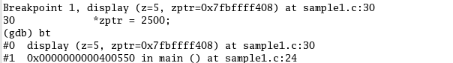

The leftmost column gives the frame id

Now, try to see the value of x (local variable of function main)
(gdb) p x
No symbol "x" in current context.

If you do want to see the value of x at this point in time, change the frame to 1 and proceed
(gdb) fr 1
(gdb) p x

What do you observe?

Analysis of core dumps
- Run the following command to see if core file creation is enabled by default
ulimit –c
If the response is unlimited, then it is enabled else run the following command to enable core file creation
ulimit –c unlimited

- When your process executes an invalid instruction, the operating system produces a core dump e.g. when the process accesses a memory location at an invalid address, the kernel sends the signal SIGSEGV to the process. If the process does not handle such a signal, the kernel writes the execution context and the contents of the address space in a file (core dump) and terminate the process.

With the help of gdb, this core file can be analyzed to see what the problem was.

Compile the file sample1_core.c

gcc –o sample_core –g sample1_core.c
(Do not name the executable as core)

Execute the file sample_core without gdb

./sample_core
Segmentation Fault (coredump)

To analyze the core file open the newly created file named as core (by the system) with gdb

gdb sample_core corefilename

#0 0x10744 in display (z=5, zptr=0x0) at sample1_core.c:29
29 printf(" zptr points to %p which holds %d.\n", zptr, *zptr);
(gdb)

The above statement shows the statement that was executed when the segmentation fault occurred. Can you see the problem why the fault occurred?

You can use the following commands while analyzing a core file:
- Display values of variables using p
- Display stack frames using bt
- Display frame information using info fr
- Switch between different frames to see the values of variables in different frames using fr

- We can analyze the core files with gdb and while we are doing that, we can save the gdb session log to a file. This will serve 2 purposes: we do not need to analyze the core file again and we can even delete the core file in case it is taking up a lot of our disk space.

To save the output of gdb commands to a file.
(gdb) set logging on
Give a few commands to gdb as discussed earlier
(gdb) shell cat gdb.txt

What do you observe?
- Remove the core files created by your process in order to save the disk space of the server.

Attaching and detaching of gdb to/from already running processes

- Compile the program bugs_wall.c
gcc –o bugs_wall –g bugs_wall.c

Run the executable as a background process
./bugs_wall &
[1] 20226
This is the process id of the process and will be used later to attach this process to gdb.

- Start gdb on a separate terminal

gdb
(gdb) att pid
pid should be replaced by the actual process id

What do you observe?
Now try putting breakpoints and controlling the program flow using gdb

- After the program is analyzed using gdb, it can be detached as follows:
(gdb) det

Gdb with multiple threads

Gdb provides these facilities for debugging multi-thread programs:
- Automatic notification of new threads: For debugging purposes, gdb associates its own thread number—a small integer assigned in thread-creation order—with each thread in your program. Whenever gdb detects a new thread in your program, it displays both gdb’s thread number and the target system’s identification for the thread

- Switching between threads: ‘thread threadno’, a command to switch among threads

- Enquiring about existing threads: ‘info threads’, a command to inquire about existing threads. The information displayed is:
  - the thread number assigned by gdb
  - the target system’s thread identifier
  - the current stack frame summary for that thread
  - One thread information is preceeded by a *. This implies the current thread under gdb

- Thread-specific breakpoints: b sourceline thread threadno, a command to put a breakpoint on a particular source statement for a specific thread given by threadno.

- Compile the program sample_threads.c

make –f make_threads

- Run the program with gdb

gdb threads

(gdb) b main
(gdb) r

Execute the program step-by-step till both the threads are created. After that see the information of all the threads:

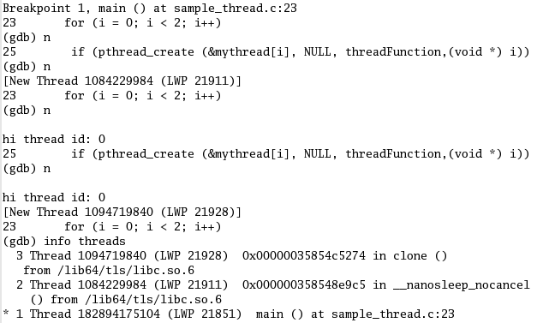

Try switching the current thread which is under gdb’s control, e.g. if thread 2 needs to be made the current thread, then

(gdb) thread 2

Try putting thread specific breakpoints. E.g. threadFunction is called by both threads 2 and 3. We can put the breakpoint on this function only for thread 3 as follows:

(gdb) b threadFunction thread 3

Whenever your program stops under gdb for any reason, all threads of execution stop, not just the current thread. This allows you to examine the overall state of the program, including switching between threads, without worrying that things may change underfoot.

Conversely, whenever you restart the program, all threads start executing. This is true
even when single-stepping with commands like step or next. Since thread scheduling is up to your debugging target’s operating system (not controlled by gdb), other threads may execute more than one statement while the current thread completes a single step.

Remember, gdb does cause your multi-threaded program to behave differently than it would without gdb.

For details on using gdb with a multiple threads program, refer the following sections in the gdb manual:
- Section 4.9: Debugging programs with multiple threads
- Section 5.4: Stopping and starting multi-thread programs
- Section 5.1.2: Watchpoints in programs with multiple threads

Gdb with multiple processes
On most systems, gdb has no special support for debugging programs which create additional processes using the fork function. When a program forks, gdb will continue to debug the parent process and the child process will run unimpeded.

However, if you want to debug the child process there is a workaround:

- Put a call to sleep in the code which the child process executes after the fork. It may be useful to sleep only if a certain environment variable is set, or a certain file exists, so that the delay need not occur when you don’t want to run gdb on the child.
- Then tell gdb (a new invocation of gdb if you are also debugging the parent process) to attach to the child process. From that point on you can debug the child process just like any other process which you attached to.

- Compile the programs fork_exec.c and child.c using the following commands:

make –f make_child
make –f make_parent

- Now start parent with gdb

gdb parent
(gdb) b main
(gdb) r

Keep stepping in the code till the fork call is executed

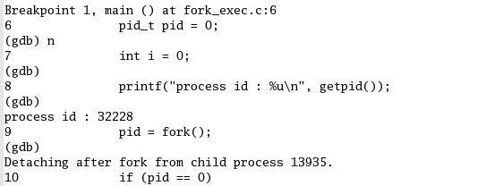

At this point in time, the process id of the child process is available. We can open gdb in another terminal and attach this process to that gdb.

gdb
(gdb) att 13935
(gdb) b myfunc
(gdb) c

Now when the child process reaches the breakpoint, it will stop and can be debugged like any other process

Gdb with C++
Since C and C++ are so closely related, many features of gdb apply to both languages. In this section we will see some features of gdb which are explicitly for C++.

The C++ debugging facilities are jointly implemented by the C++ compiler and gdb. When using g++ compiler, use the dwarf 2 debugging format. If that doesn’t work on your system, try the stabs+ debugging format.

- Compile the file sample.cpp

g++ -o sample1 –gdwarf-2 sample.cpp

- Catchpoints can be used to stop the program when certain kinds of program events, such as C++ exceptions occur.

gdb sample1
(gdb) b main
(gdb) r

(gdb) catch catch
This command will cause the debugger to stop whenever an exception is caught

(gdb) catch throw
This command will cause the debugger to stop whenever an exception is thrown

(gdb) c

When the program stops because an exception is thrown, see the stack trace using bt

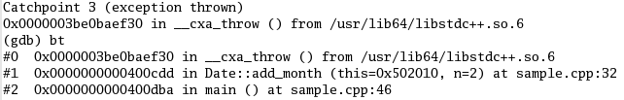
(gdb) c

When the program stops because an exception is caught, see the stack trace using bt

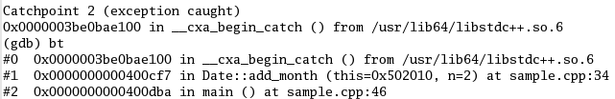

Refer section 12.4.1 of the gdb manual for detailed information on gdb with C++

Good to know

Redirecting the output of the program
- While executing a file with gdb, it is possible to redirect the output of the program to another file
(gdb) r > output

Quit gdb
(gdb) q

View the Output file
cat output
Listing the source code
- To have a look at the source code at any point in time
gdb sample
(gdb) list

By default the number of lines displayed is 10, to change the number of lines to be displayed
(gdb) set listsize 20
(gdb) list

Information on breakpoints. Deleting, disabling and enabling breakpoints
- Information of all the set breakpoints can be seen
(gdb) info b
The first column shows the id of the breakpoint

- Delete the breakpoints
(gdb) d b id1 id2 …

- p command can also be used to alter the value of a variable
(gdb) p *zptr
(gdb) p z
(gdb) p z = 10
(gdb) p *zptr = 25

p command can also be used to compute an expression or a function
(gdb) p strlen(“abc”)
$4 = 3

- Breakpoints can be disabled and enabled using the following commands:

(gdb) dis id
(gdb) en id
Check the status of the breakpoint after disabling and enabling the breakpoint

Ignore, conditional breakpoints, finish and Until commands
- Commands to explore,
(gdb) help command name
  - ignore command with breakpoints: ignore id number of times to be ignored
  - Conditional breakpoints: e.g. b main if x==6, b display if z==5
  - finish command: Continue running till the current stack frame reaches its end
  - Until command: Continue running until a source line past the current line, in the current stack frame, is reached.
(gdb) b main
(gdb) r
(gdb) until 16

What code scenarios can you think where the “ignore” and “until” commands can be used?

Shell commands on gdb prompt
- Execute shell commands on the gdb prompt
(gdb) shell cat sample1.c

Telling gdb the path of the source code
- Try moving your source file sample1.c to some other directory
(gdb) shell mv sample1.c ../
(gdb) r
sample1.c: No such file or directory
(gdb) dir ../
(gdb) n

Putting often used gdb commands in a file
- The same commands need not be typed again and again on each invocation of gdb but take the input from a file. Create a file called commands with the following lines :
b main
b display
Now run sample with gdb
gdb sample
(gdb) sou commands

Gdb initialization commands
- When gdb starts, it automatically reads /.gdbinit if it exists, then .gdbinit in the current directory, if it exists. Thus you can customize gdb to your own liking, and also customize it for each project (assumed to be in a separate sub-directory). These files can contain any gdb commands as you would type them in gdb. Any line starting with a # is a comment, and blank lines are ignored.

